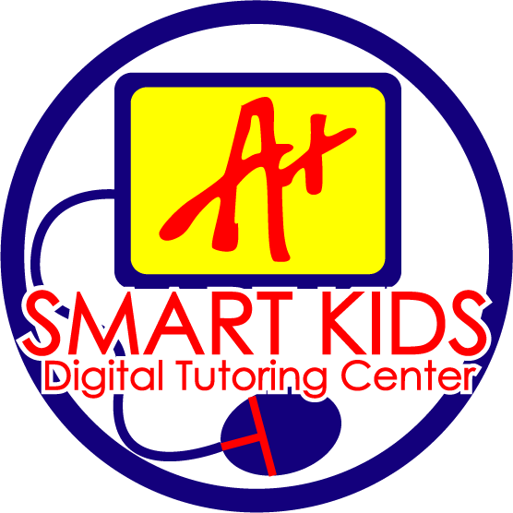
SMART KIDS DIGITAL TUTORING CENTER

556 W. 31st Street, Chicago, IL 60616 Tel: 312-225-3828

Website: www.SmartKidsInc.com (K-12) E-mail: SmartKidsTutoring@gmail.com

June 24, 2020

To Smart Kids families and students:

Smart Kids, Inc. will be opening our tutoring center, located at 556 W. 31st Street, and welcoming backs all of our longstanding students and hope to see new students enroll on July 1, 2020. We are re-opening our year-round A+ math & Reading tutoring programs to students in elementary & high schools. Please let your extended families and friends know. We will not have a summer program this year.

To ensure safety and cleanliness at the Smart Kids Digital Tutoring Center we will:

- Students are seated at every-other-work station (as a result, enrollment is limited and enrolled on a first-come, first-serve basis)
- Student work surfaces and computers are disinfected after every use
- Classrooms are thoroughly cleaned daily
- Bathrooms surfaces, door handles that students frequently touch, floors and common areas are sanitized at the end of each day

Be advised that:

- All young people experience learning losses when they do not engage in educational activities during the summer.

- On average, students lose approximately 2.6 months of grade level equivalency in mathematical computation skills over the summer months.

Along with The Chicago Public Schools and the Illinois Department of Public Health, Smart Kids will be sending out information to our families, students, and staff with guidance on preventing the spread of the corona virus, which include:

- Thoroughly washing hands for at least 20 seconds
- Using hand sanitizer when washing hands with soap and water is not available
- Wearing mask when 6-foot social distancing is not possible
- Disinfecting surfaces
- Staying home if you are sick
- Contacting your doctor to see if you should be tested for the corona virus

Please give us a call at 312-225-3828, or email us at SmartKidsTutoring@Gmail.com, or leave a message for us on our website: www.SmartKidsInc.com for more information.
Sincerely,

SmartKids Inc.

We help students Catch Up, Keep Up, & Get Ahead! We are 100% Successful!

